**LAB REPORT NO 5**



**CSE-206L Electronic Circuits Lab**

Submitted by:  **Muhammad Ali**

Registration No: - **19PWCSE1801**

Class Section: A

“On my honor, as student of University of Engineering and Technology, I have neither given nor received unauthorized assistance on this academic work.”

Submitted to:

**Engr. Abdullah Hamid**

Data:(06,06,2021)

Department of Computer Systems Engineering

University of Engineering and Technology, Peshawar

**Series Positive negative clipper: -**

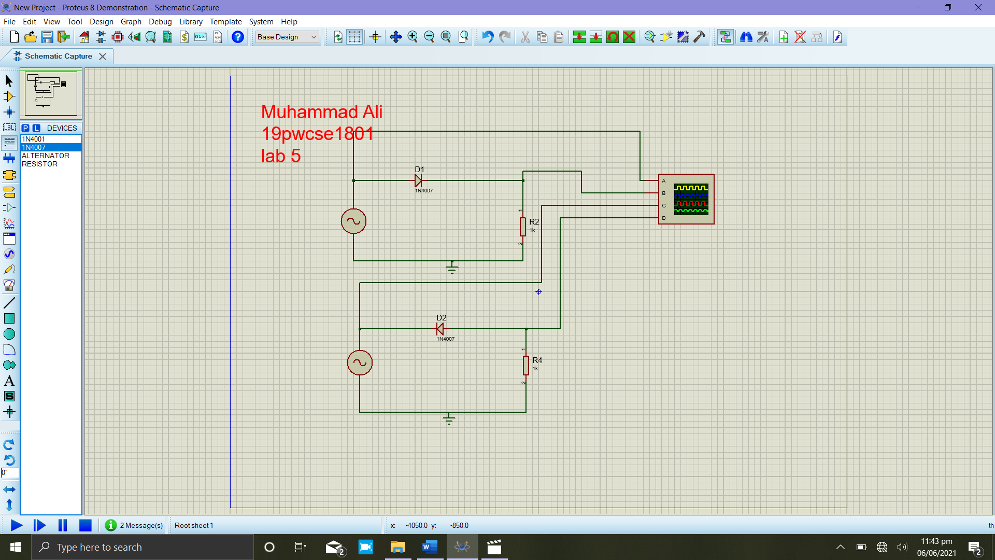

**Graph: -**

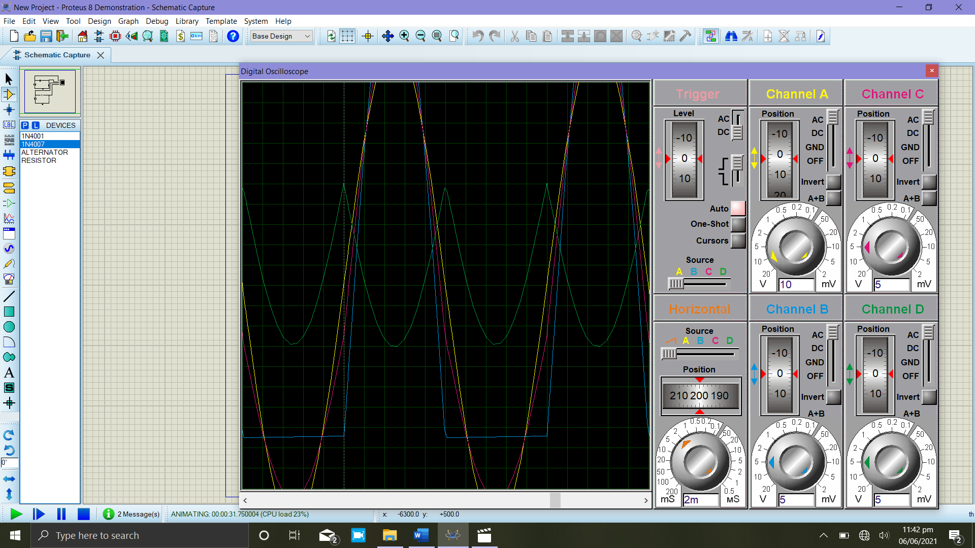

**Parallel Positive negative clipper: -**

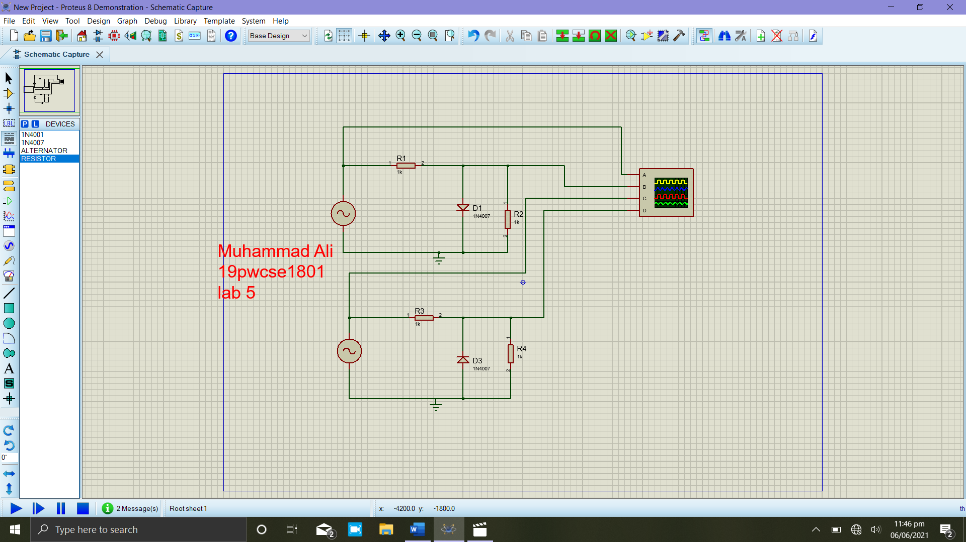

**Graph: -**

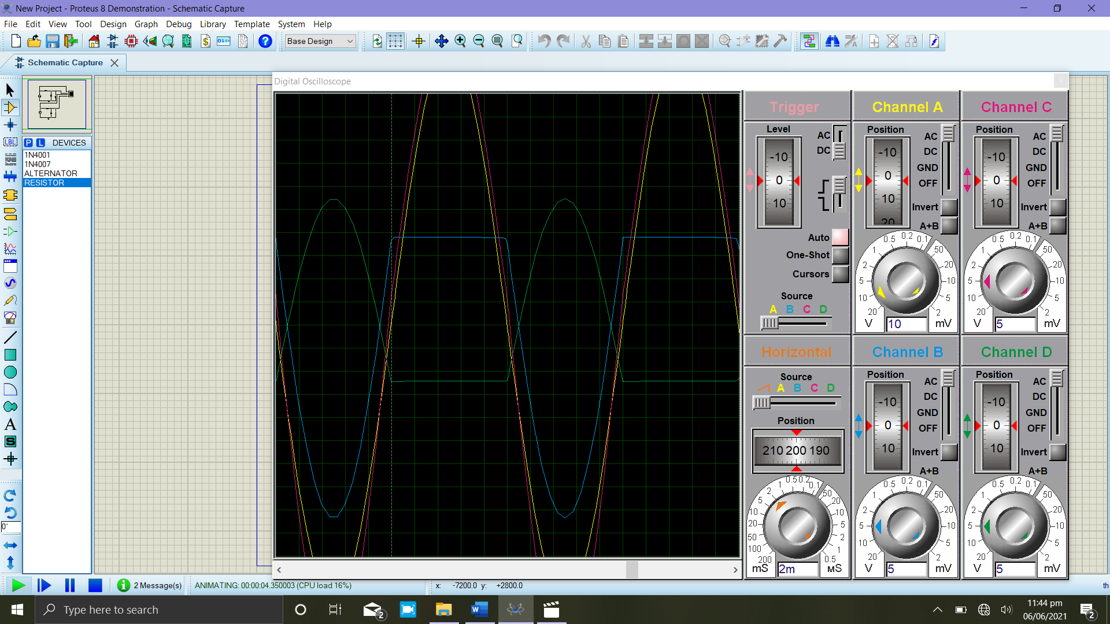

**Bias clipper: -**

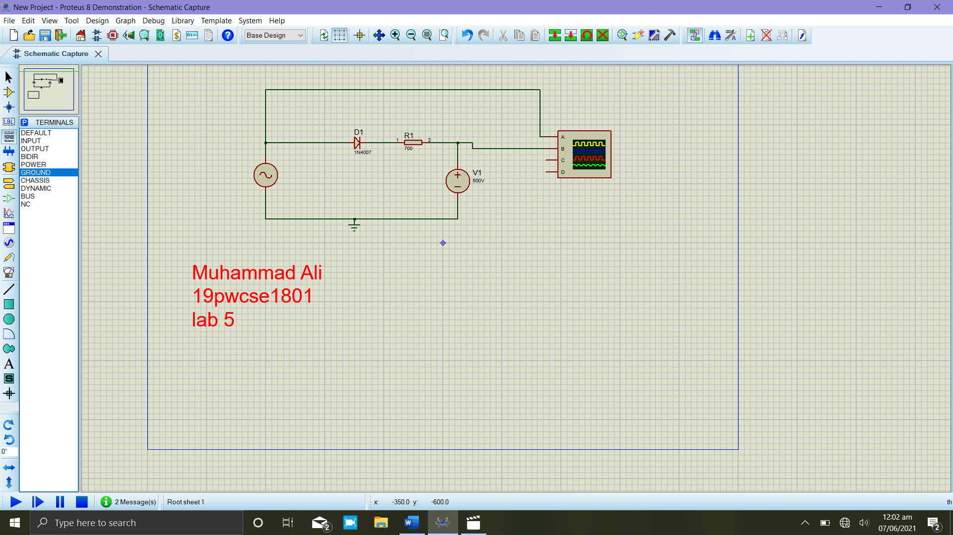

**Graph: -**